T-TEST

**FUNDAMENTALS, TYPES, KEY POINTS**

T-test, F-test, Chi-square all are a part of **inferential statistics**. Sounds heavy? Let us break this down. 

**‘Inferential statistics in simple terms is a branch of statistics that uses a random sample of data taken from a population and makes inferences or conclusions about the population’.**

Inferential statistics is strongly associated with the logic of **hypothesis testing** which is an act by which one tests an assumption regarding a population parameter. In hypothesis testing, main aim is usually **to reject the null hypothesis** or the assumption that there is no significant difference between specified populations.

Coming to T-test, F-test and Chi-square, these are only a few examples of inferential statistics. Here, we will be focusing on the **t-test**.

**T-test is simply used to determine whether there is a significant difference between the means of two groups.** This difference helps us to test if the two samples are statistically different from each other.

Let’s consider an example to understand this further: 

A drug company wants to test a new medicinal drug to find out how much time it takes to cure a disease.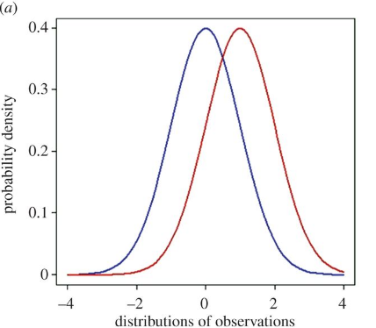

So, like other experiments this will have a control group who would be given a placebo/sugar pill while the other group would be given the new drug. 

Then results for both would be taken. Suppose, it is noted that the disease is cured within a week for the control group, while the group taking the new drug gets cured in 5 days, it would seem that the new drug is working. However, that could be a fluke.

Thus, to test this the company would use a t-test or a student’s t-test to find out if the results can occur again for an entire population.

**ASSUMPTIONS UNDERLYING T-TEST:**

1. The dependent variable fits a **normal distribution**.
2. The samples selected are **randomly drawn** from their respective populations.
3. The scores in the populations have the **same variance** i.e. S1=S2. (If not then we use a different calculation).

**TYPES OF T-TEST:**

















